Section 7 – Firebase + User authentication

89. Section Overview

90. Firebase intro

a. Backend development is related to database, authentication and server.

B b. Database is an storage; server determines the most efficient way of requesting | fetching data from db. Authentication

confirms the correctness of the query.

91. Important Note

92. Adding project to Firebase

a. Sign in to firebase using google acct

b. Press go to console >>> create and name a project

c. Configure the firebase. Click web </> in the project overview page >>> register the app (no need to setup the hosting) >>>

copy and paste the code snippet object from the script given by firebase in the firebase.utils.js

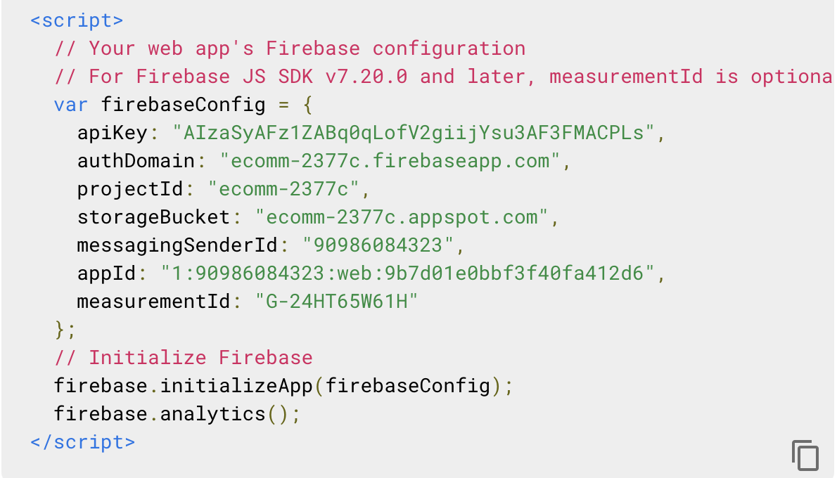

d. in the terminal npm I firebase

93. Note about firebase

94. Google Sign In Authentication – **firebase configuration**

a. Create the src/firebase/firebase.utils.js. The code snippet from firebase is needed here. It can be retrieved in Project Overview

then click the app

b. In firebase.utils.js

i. import firebase from ‘firebase/app’. <<< this is to pull in the firebase utility

ii. import ‘firebase/firestore’ << storage

iii. import ‘firebase/auth’ << authentication

iv. ii & iii care utilities that came from firebase/app that is needed in the app

v. const config = {} use the code snippet as an object of const config (92c.)

vi. firebase.initializeApp(config)

vii. export const auth = firebase.auth()

viii. export const firestore = firebase.firestore()

c. Setup the google sign in utility

i. const provider = new firebase.auth.GoogleAuthProvider()

ii. provider.setCustomParameters({.prompt: ‘select_account’ }) <<< this will trigger the google pop up whenever we use

the GoogleAuthProvider for authentication and signin

iii. export const signInWithGoogle = () => auth.signInWithPoup(provider)

iv. export default firebase

h. enable the Google authentication. Go to Project Overview > Authentication tab



i. In the Signin.jsx

i. import { signInWithGoogle } from ‘../../firebase/firebase.utils.js’

ii. then create another <CustomButton onClick={ signInWithGoogle } > Sign In With Google </CustomButton> in the

<SignIn> component.

k. Google will handle the authentication from here. See below full code in firebase.utils.js

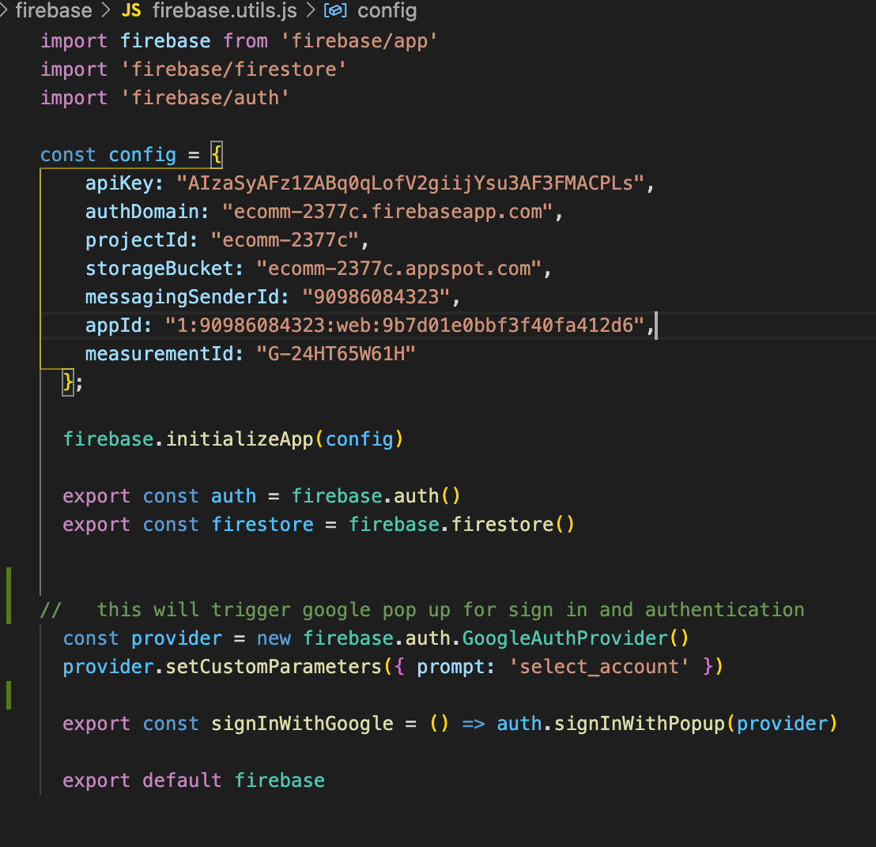

95. Cloning from this point on

Above firebase.utils.js can be reuse in different project as long as to use different code object snippet.

96. Google Sign in authentication 2

**This will enable the App to know if the user already sign in and be able to store the data to database.**

a. Verify the signInWithGoogle function by checking it in the user tab of the firebase console.

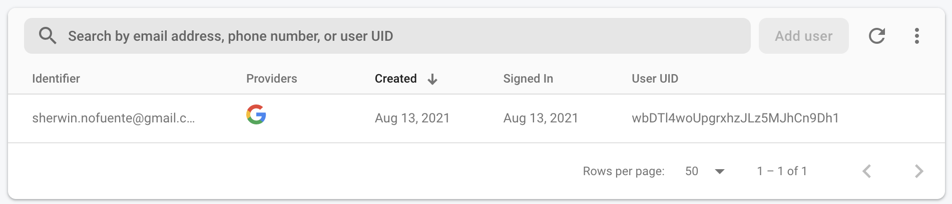

b. Let the application know that the user had signed procedure:

i. In App.js, import { auth } from ‘./firebase/firebase.utils’ in <App>.

ii. Convert the <App> to class component

iii. Store the state of the user in the <App>, this.state = { currentUser: null }

iv. **currentUser** is a customise term for this authentication result. At first it’s unknown that’s why it was null.

c. the componentDidMount(){ auth.onAuthChange } was use so that the <App> will now whether there’s an update with the

state. Fetch was not use as we do not want the App to re render. This was given by the method auth.onAuthChange; this is a method from the auth library of the firebase.

i. onAuthChange is a method from the firebase.auth library. It serves as a subscription or open connection that ket the app knows if the user signed in or signed out. This needs to be close as well so as not to have a memory leak. See (e)

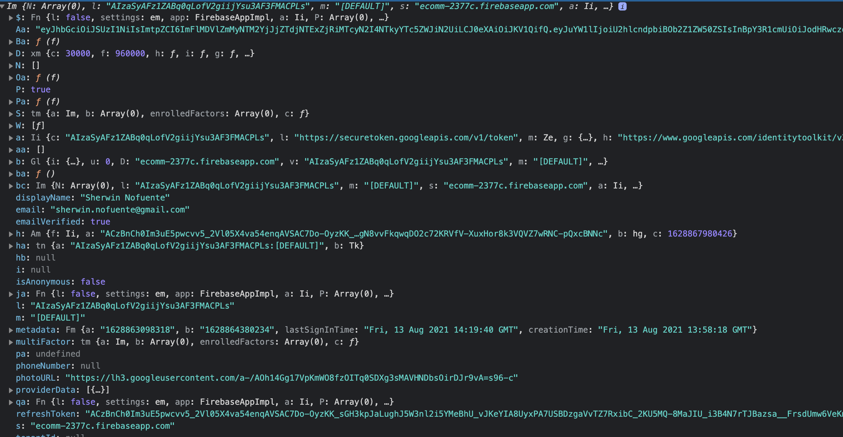

d. Above show us the state of the <App>

i. the onAuthChange takes a function with the parameter (user => { this.setState({ currentUser: user }) }) is the state of the user

auth that is coming from firebase.

ii. this is user authentication session persistence which is a feature from firebase. this will eliminate the instances of re-signing in

if the page refresh or if the page close and then open it up again.

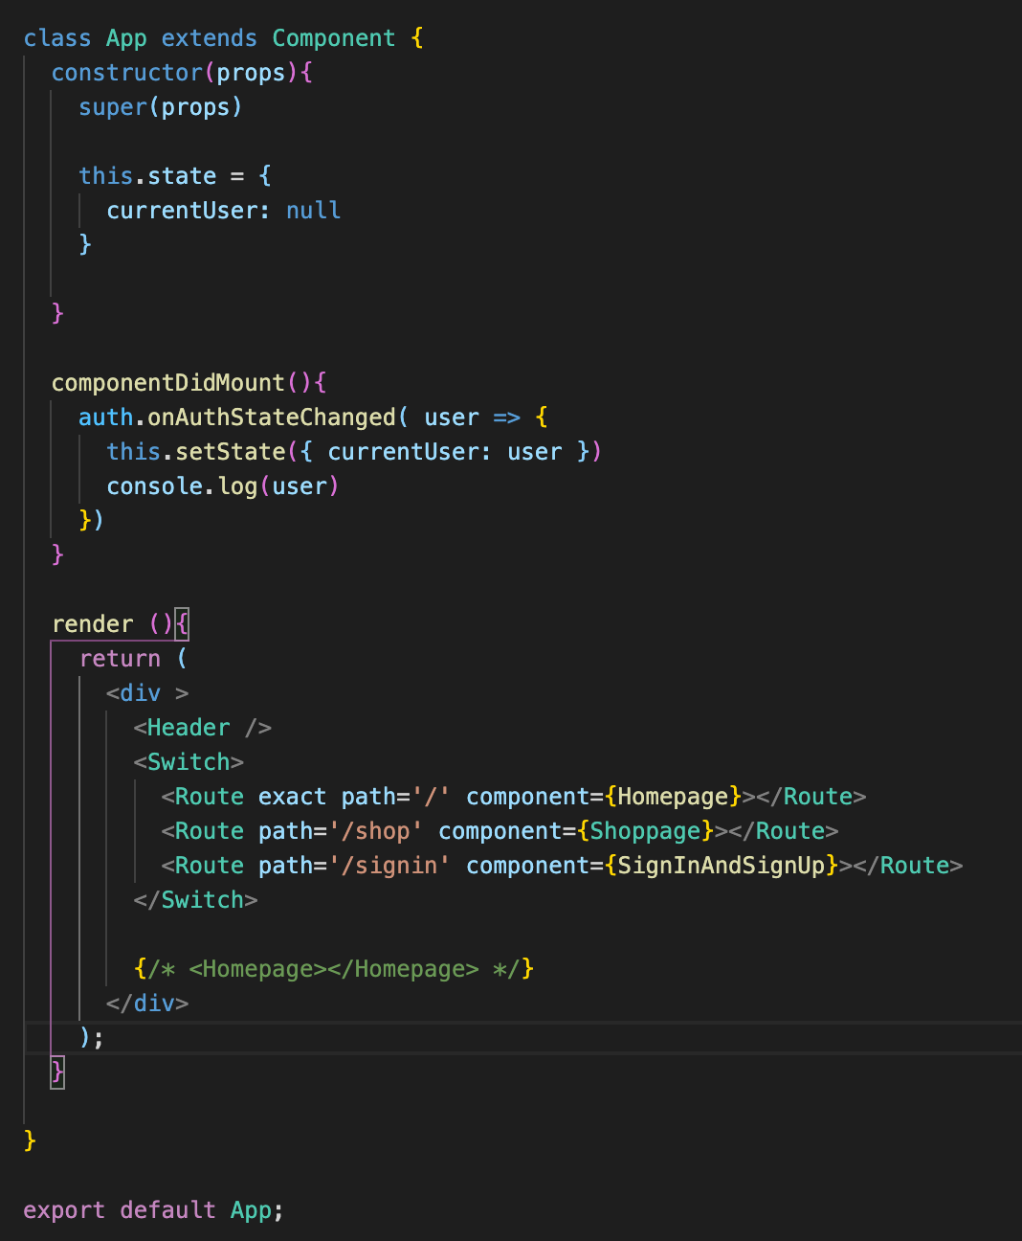 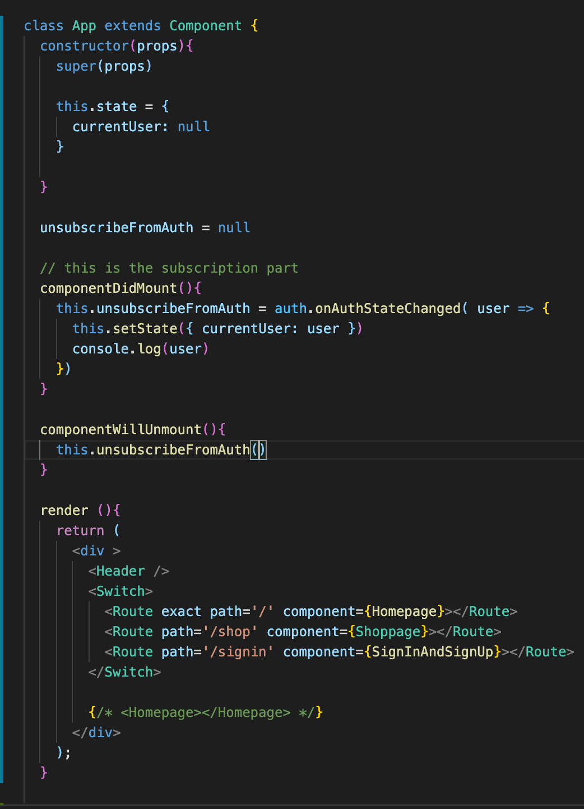

e. unscribeFromAuth = null and componentWillUnmount(){this.unsubscribeFromAuth()} will ensure that there’s no memory leak

after signed out.

97. Optional

98. Google Sign In Authentication 3

**At this point the Goggle Authentication is active and the App manage to listen to auth state change feature from firebase, next**

**is the sign out feature of the application.**

a. Signing out

b. Make the Header aware of the currentUser state by passing this as a props <Header currentUser={this.state.currentUser} />

c. import { auth } from ‘./firebase/firebae.utils’ in <Header />

d. Destructure the passed currentUser in the header({ currentUser }){} and use it in the ternary operation to display either a <div>

or <Link>. The ternasry operation ealuates the currentUser object that was passed to <Header> if the object has a content, it will display a <div className=”option” onClick={ () => auth.signout() }> and if none, it will render a <Link className=”option” to=”/signin”>

e. currentUser is props from the <Header> while in the <App>

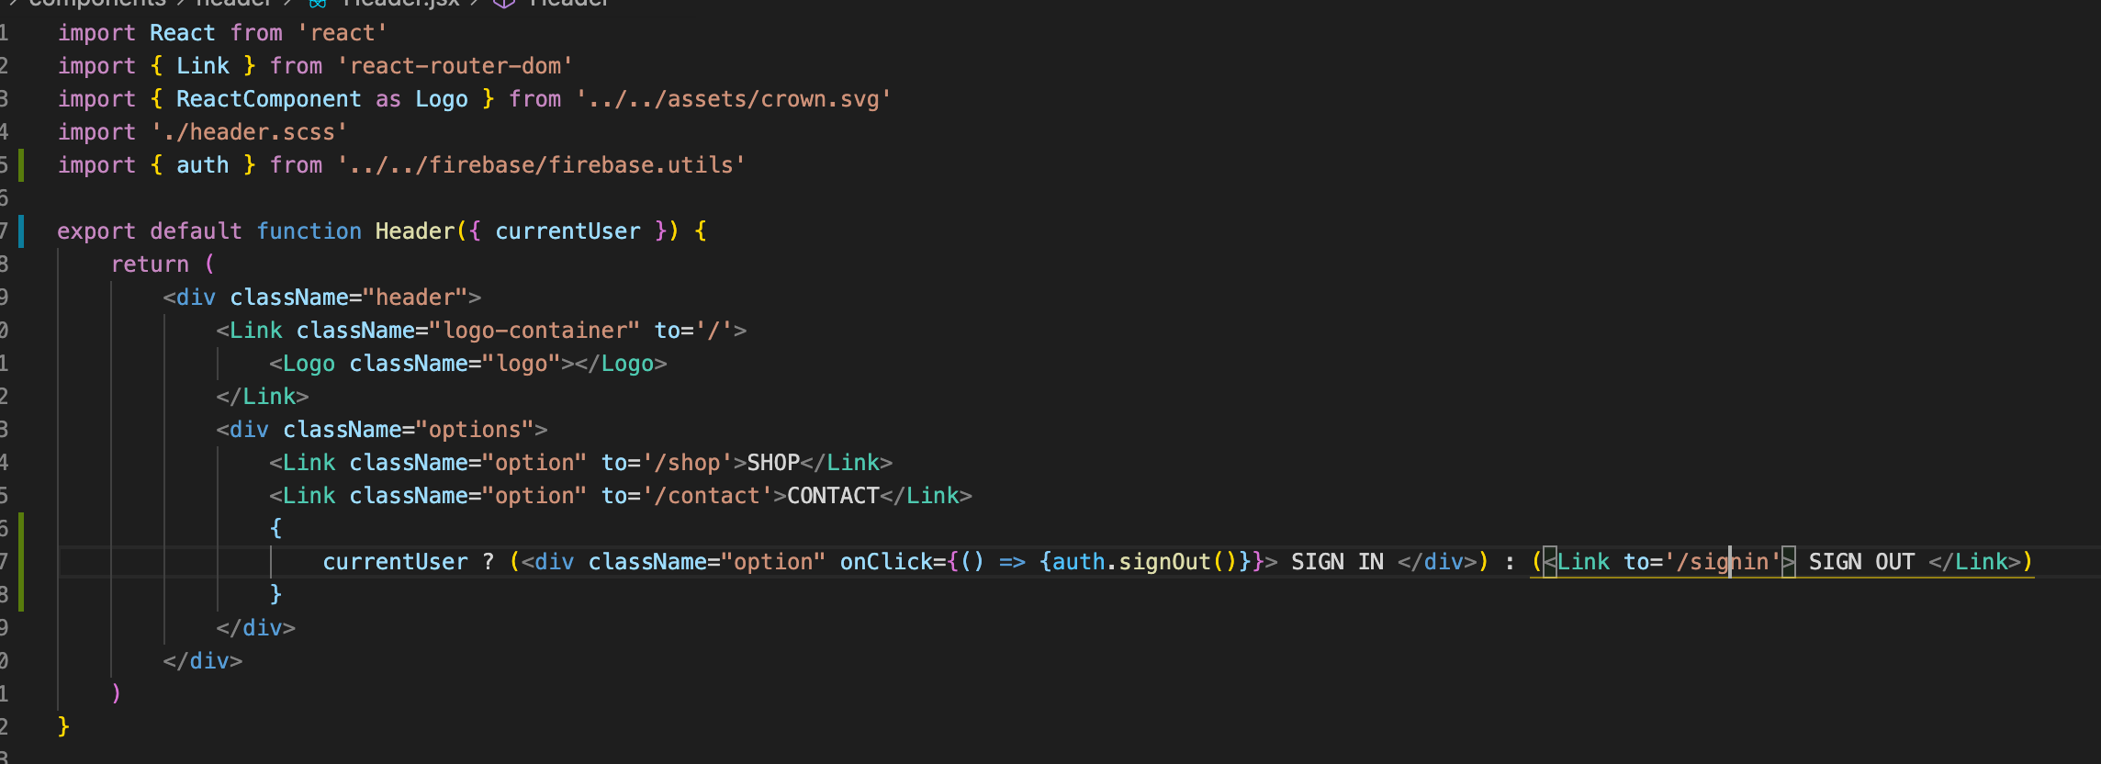

f. Style and put condition to <CustomButton />. In <CustomButton>, Pass the props isGoogleSignIn and use it to conditionally

render the <CustomButton>.

g. 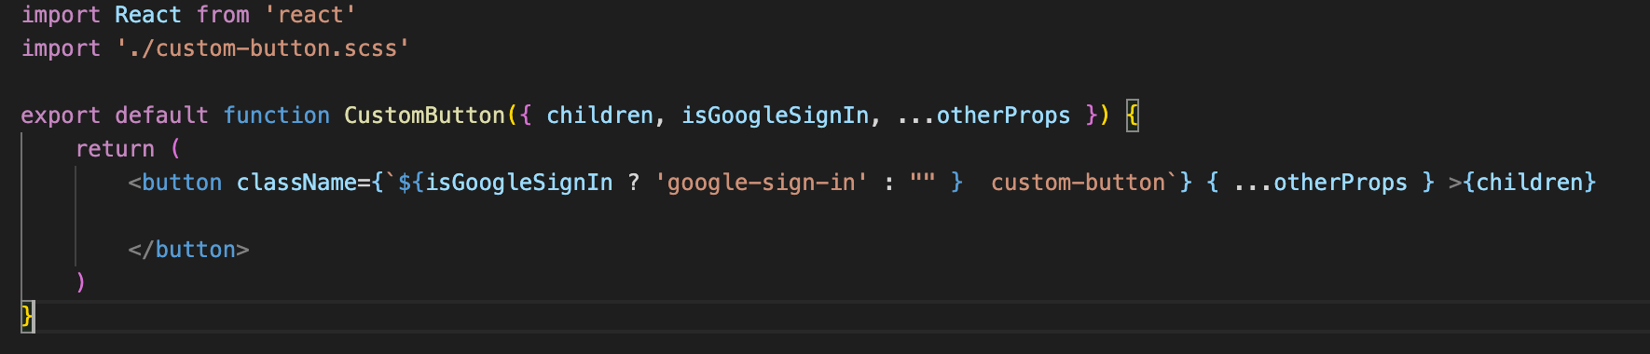

h. then style the .google-sign-in {}

i. apply isGoogleSignIn in the <Signin> <CustomButton onClick={ signInWIthGoogle } isGoogleSignIn}

j. fix the width of the <Signin>; then wrap the <CustomButton> in a <div className=”button” />

k. apply box-sizing: border-box in the App.css

l. At this point commit. Created the sign in page with sign-in component & sign in with google.

99. Note

100. Firebase Firestore

a. in the FB Console click database > Create database

b. Security rules: Lock or Test Modes

c. Start in Test Mode type of security

d. 2 types of data = collection, group of objects that consists of documents; other data is documents. Inside a document can also

create a collection.

e. create the collection named users as below.

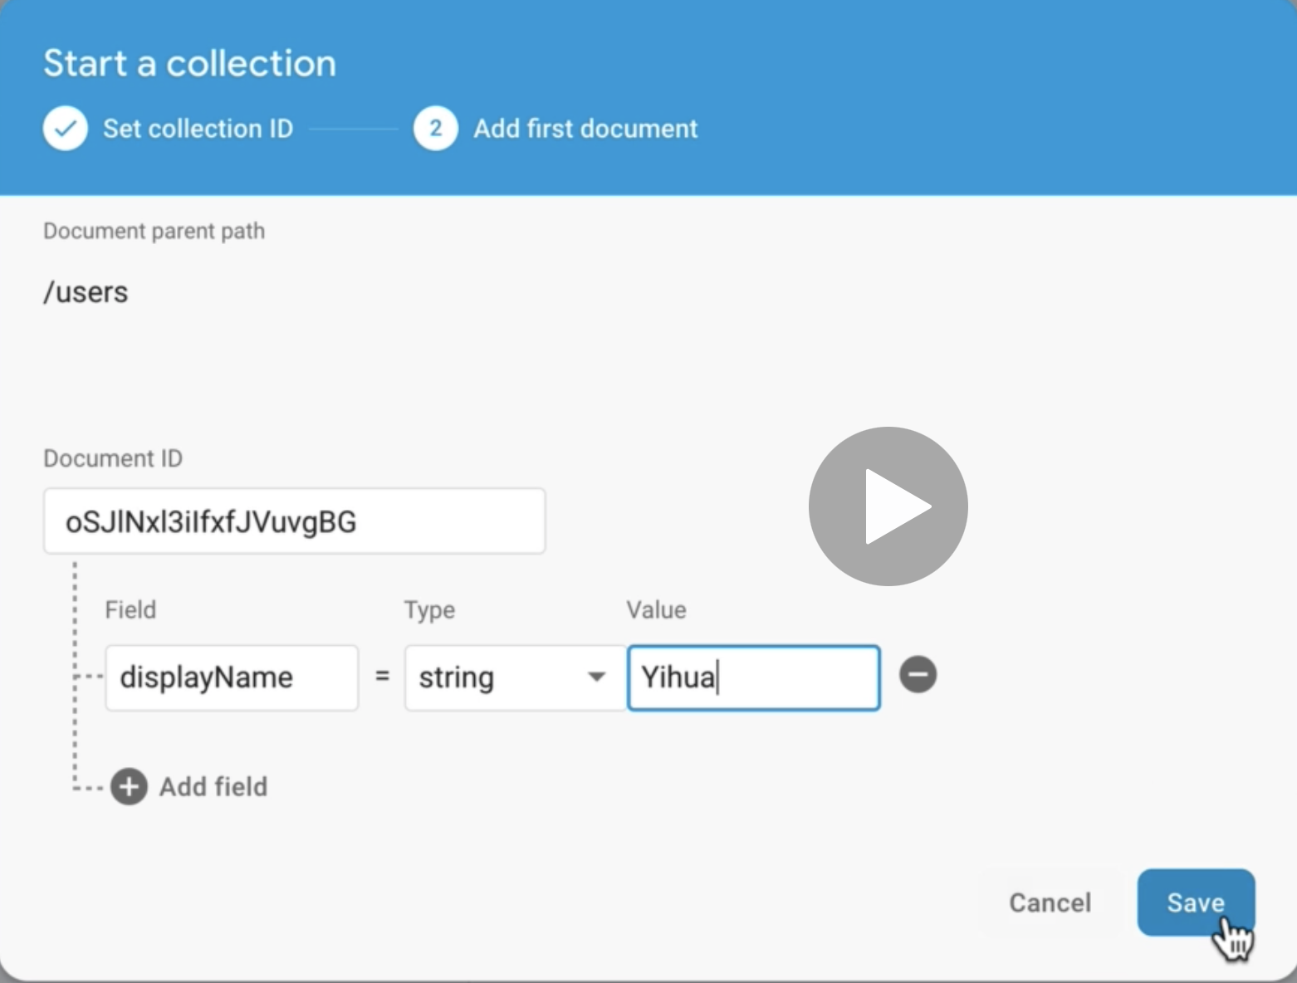

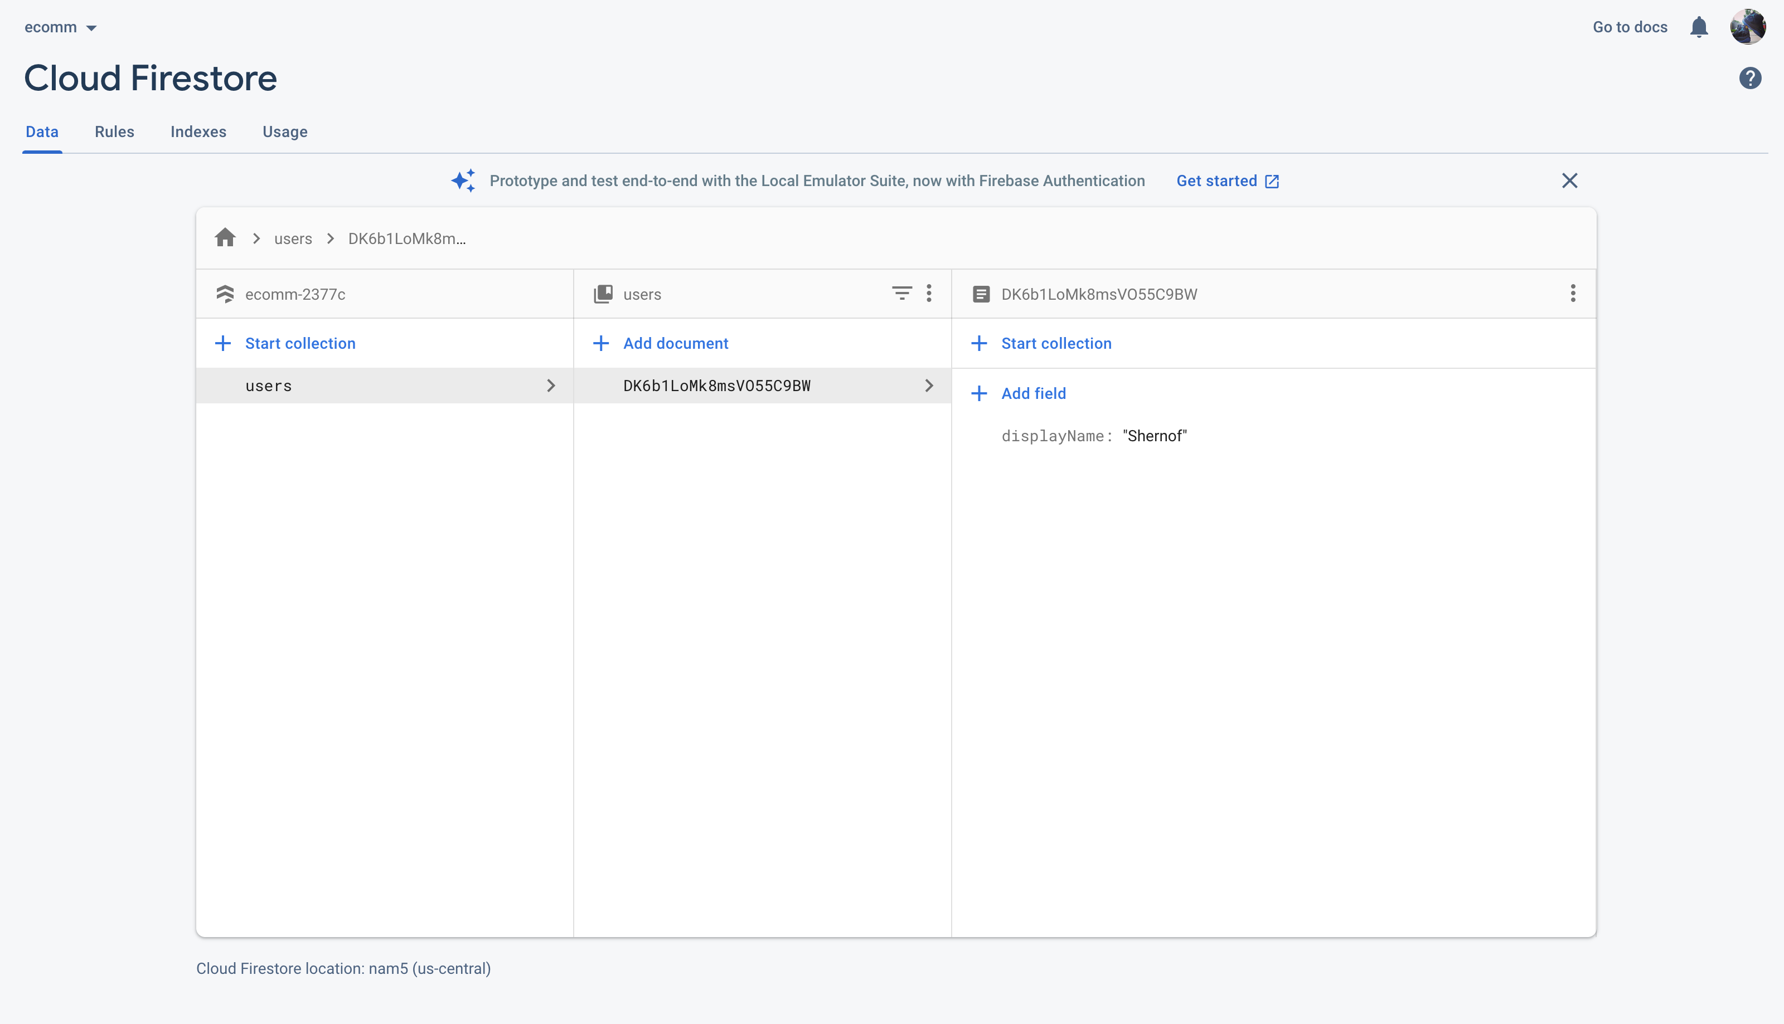

f. create the cartItems collection inside shernof document

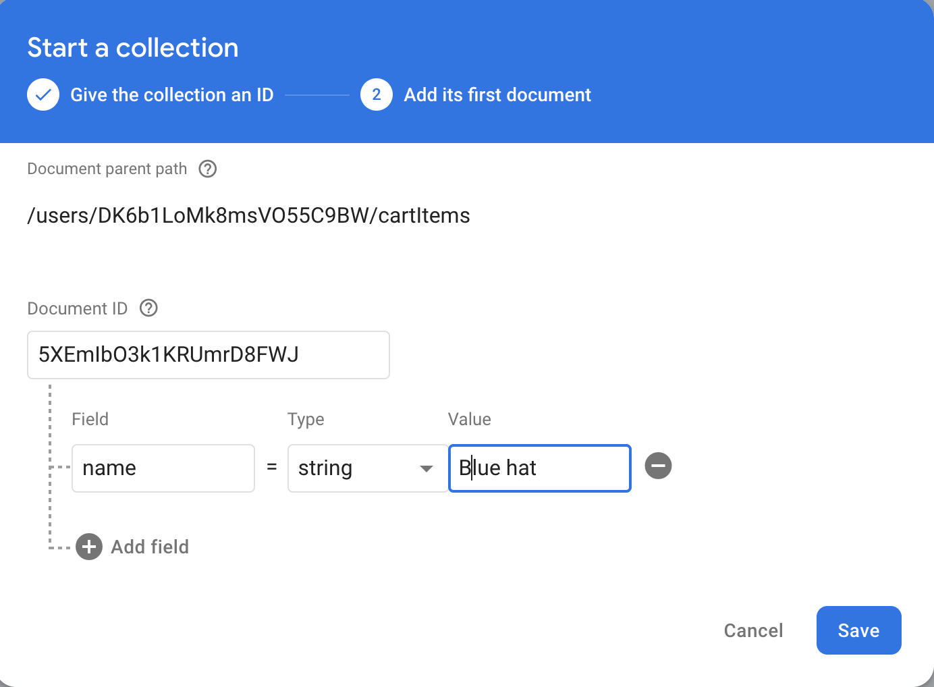

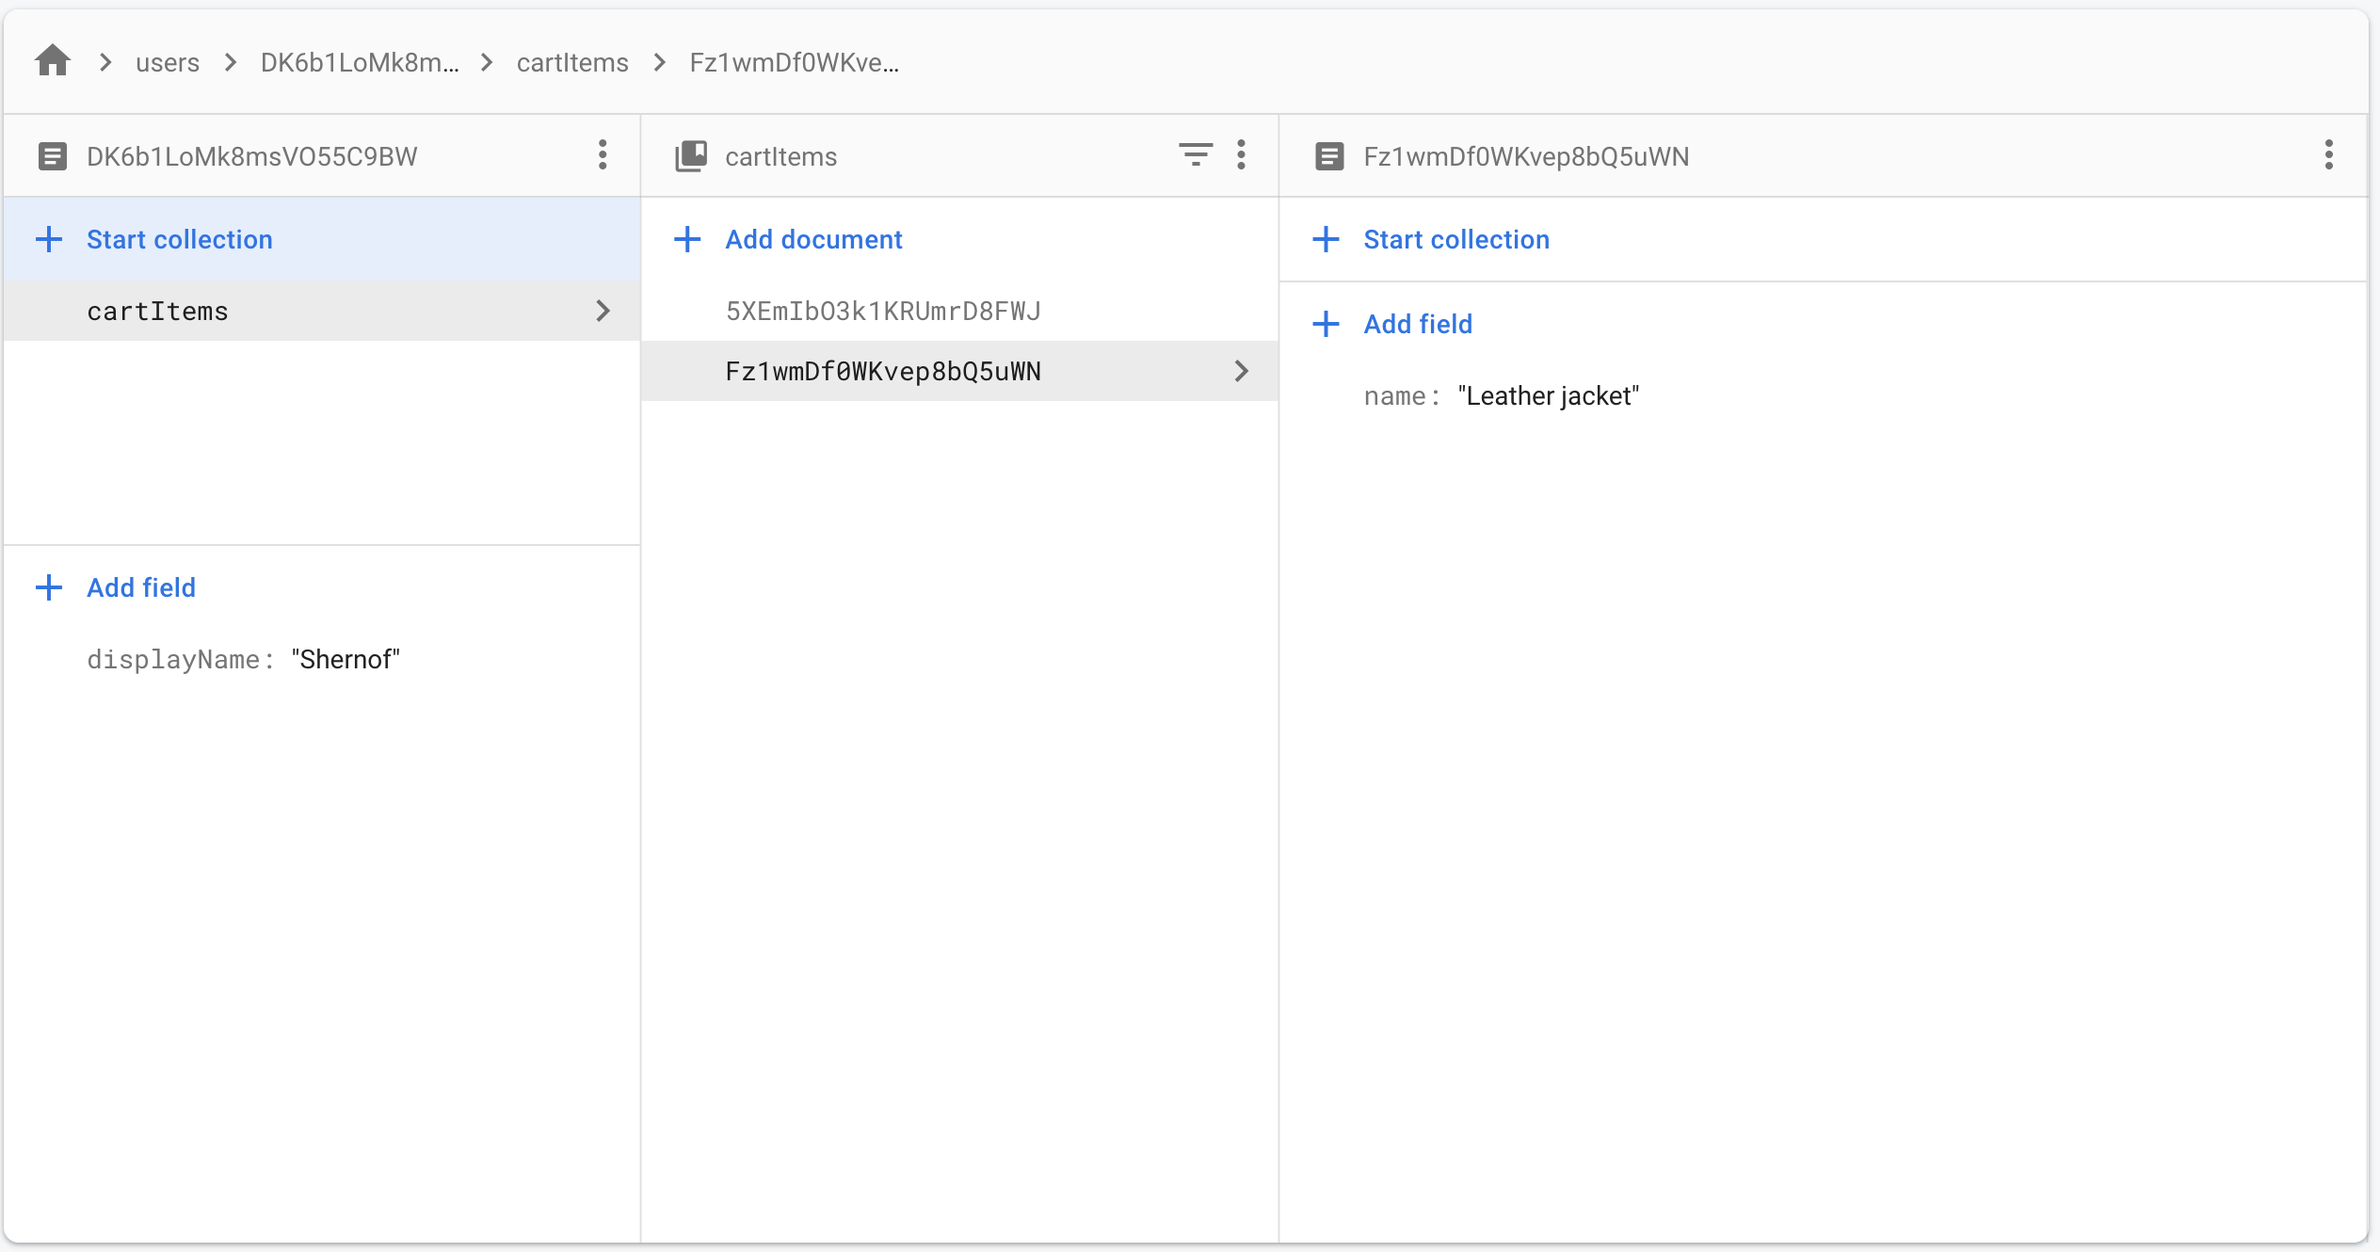

g. Methods in getting documents and collections in database

firestore.collection(‘users’).doc(‘DK6b1LoMk8msVO55C9BW’).collection(‘cartItems’).doc(‘5XEmIbO3k1KRUmrD8FWJ’)

firestore.doc(/users/ DK6b1LoMk8msVO55C9BW/cartItems/5XEmIbO3k1KRUmrD8FWJ’’)

firestore.collection(‘/users/DK6b1LoMk8msVO55C9BW/cartItems’)

**h. Store the authenticated user from auth library to db**

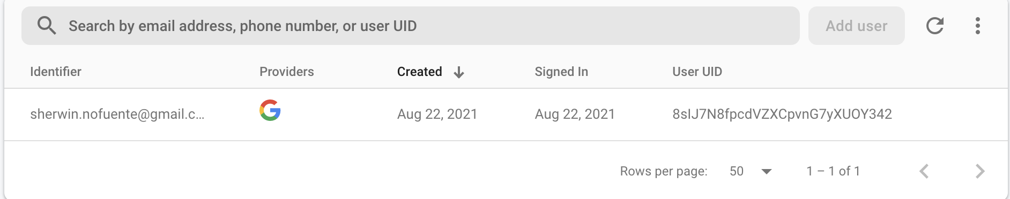

i.

101. Optional: Async & await

102. **Storing user data in Fb**

a. Store the authenticated user object into database. This will enable for the app to use the information about the user.

At this point this authenticated users are only in the auth library and not yet in the db.

The auth library returns an object with so many unwanted properties. What are needed are displayName, email and uid.

Basically it needs to define what information are needed from this auth object and store it in db.



b. Understanding the firestore database and procedures to add data to firestore. Configure it in firebase.utils.js

i. function to allow to take the user auth object and save it to db =

export const createUserProfileDocument = async (userAuth, additionalData) => {

if(!userAuth) return <<< this will check if the user is signed in, if not signed in the App will not do anything.

const userRef = firestore.doc(`users/$userAuth.uid`). <<<< this is querying the users document

const snapShot = await userRef.get() <<< this is getting the content of the queried object. From here the uid from firestore is now being returned to app

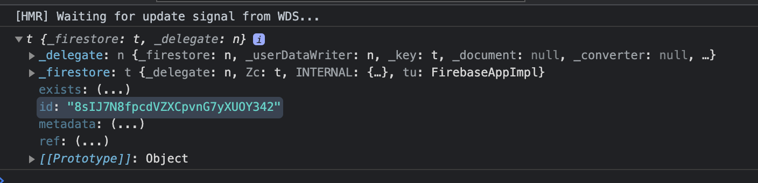

If(!snapShot.exists){

Const { displayName, email } = userAuth

Const createdAt = new Date

Try {

Await userRef.set({

displayName,

email,

createdAt,

…additinalData

})

} catch(error) {

Console.log(‘error creating user’, error.message)

}

} <<< this functions create the document if there’s no user yet presented by the snapshot. If none then it will

create the document via DocumentReference .set()

}

userAuth is the object from the auth library

if(!userAuth) return = is checking the availability of userAuth object. If no userAuth do nothing, if there is then evaluate

the object that will be potentially return by FS. These objects are QueryReference & QuerySnapshot, explained as below.

Of these objects can be either collections or documents.

QueryReference and QuerySnapshot are the potential objects that the firebase will return for every query.

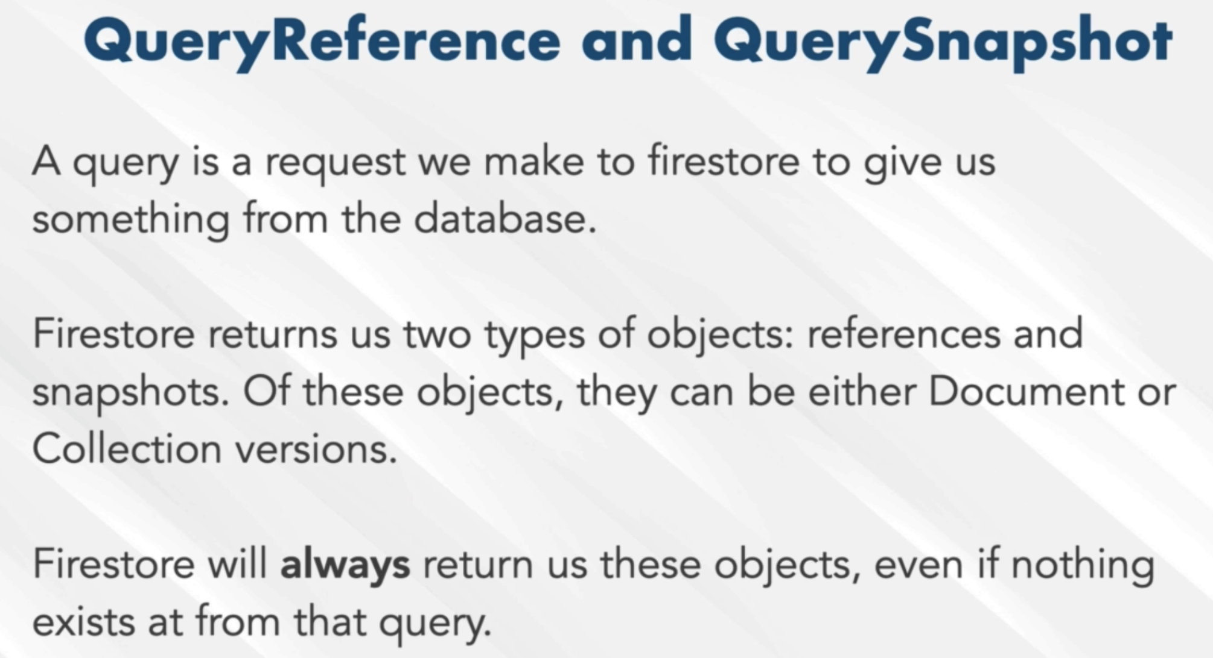

Query Reference is not the data, it just represents the data.

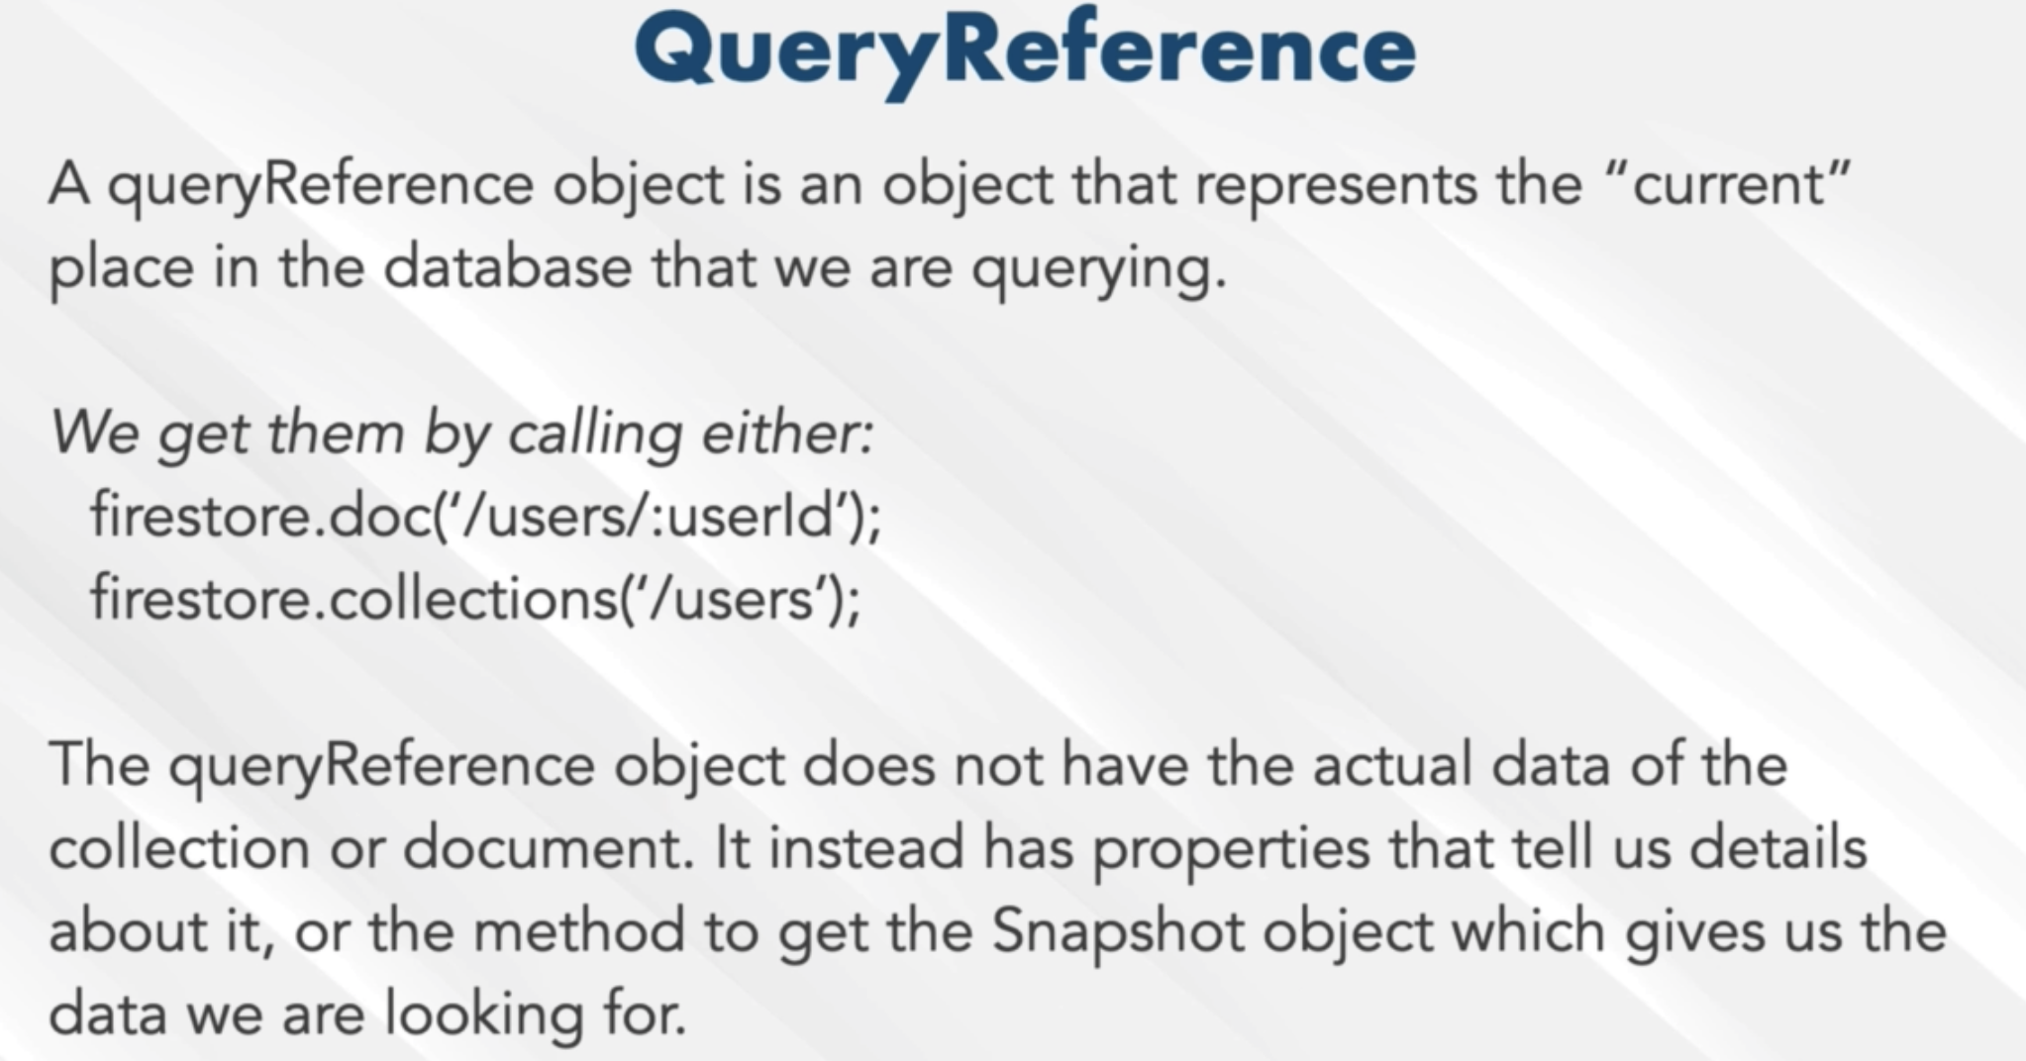

b. import the createUserProfileDocument to <App> >>> componentDidMount(){}

c. from below the user will turn to userAuth as this is the data that came from FB.

d. if(userAuth){ <<< is a check to see if there is a userAuth or if the user is signed in or not. This will define the state of the

currentUser from createUserProfileDocument(userAuth)

e. onSnapShot is an auth method used to display or present the snapshot of the object and will be use to define the state of the

currentUser. This will still give a snapshot of the data that is stored in the db once it initiated. This is where the data will come from with regards to the information needed to be store for the user whether it is already existed or not.

g. userRef is a reference query imported from firebase.utils.js

h. snapshot only give the id and exists properties. snapshot.data() gives the details like displayName, email and uid

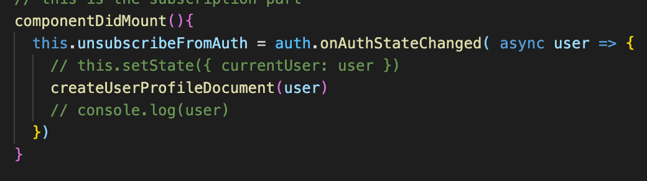

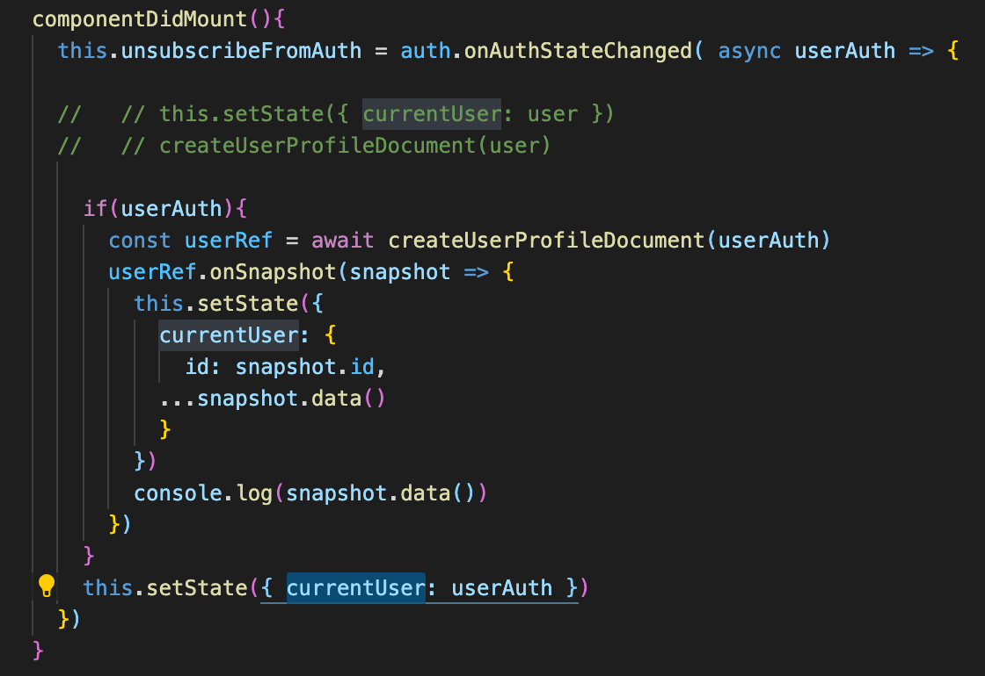

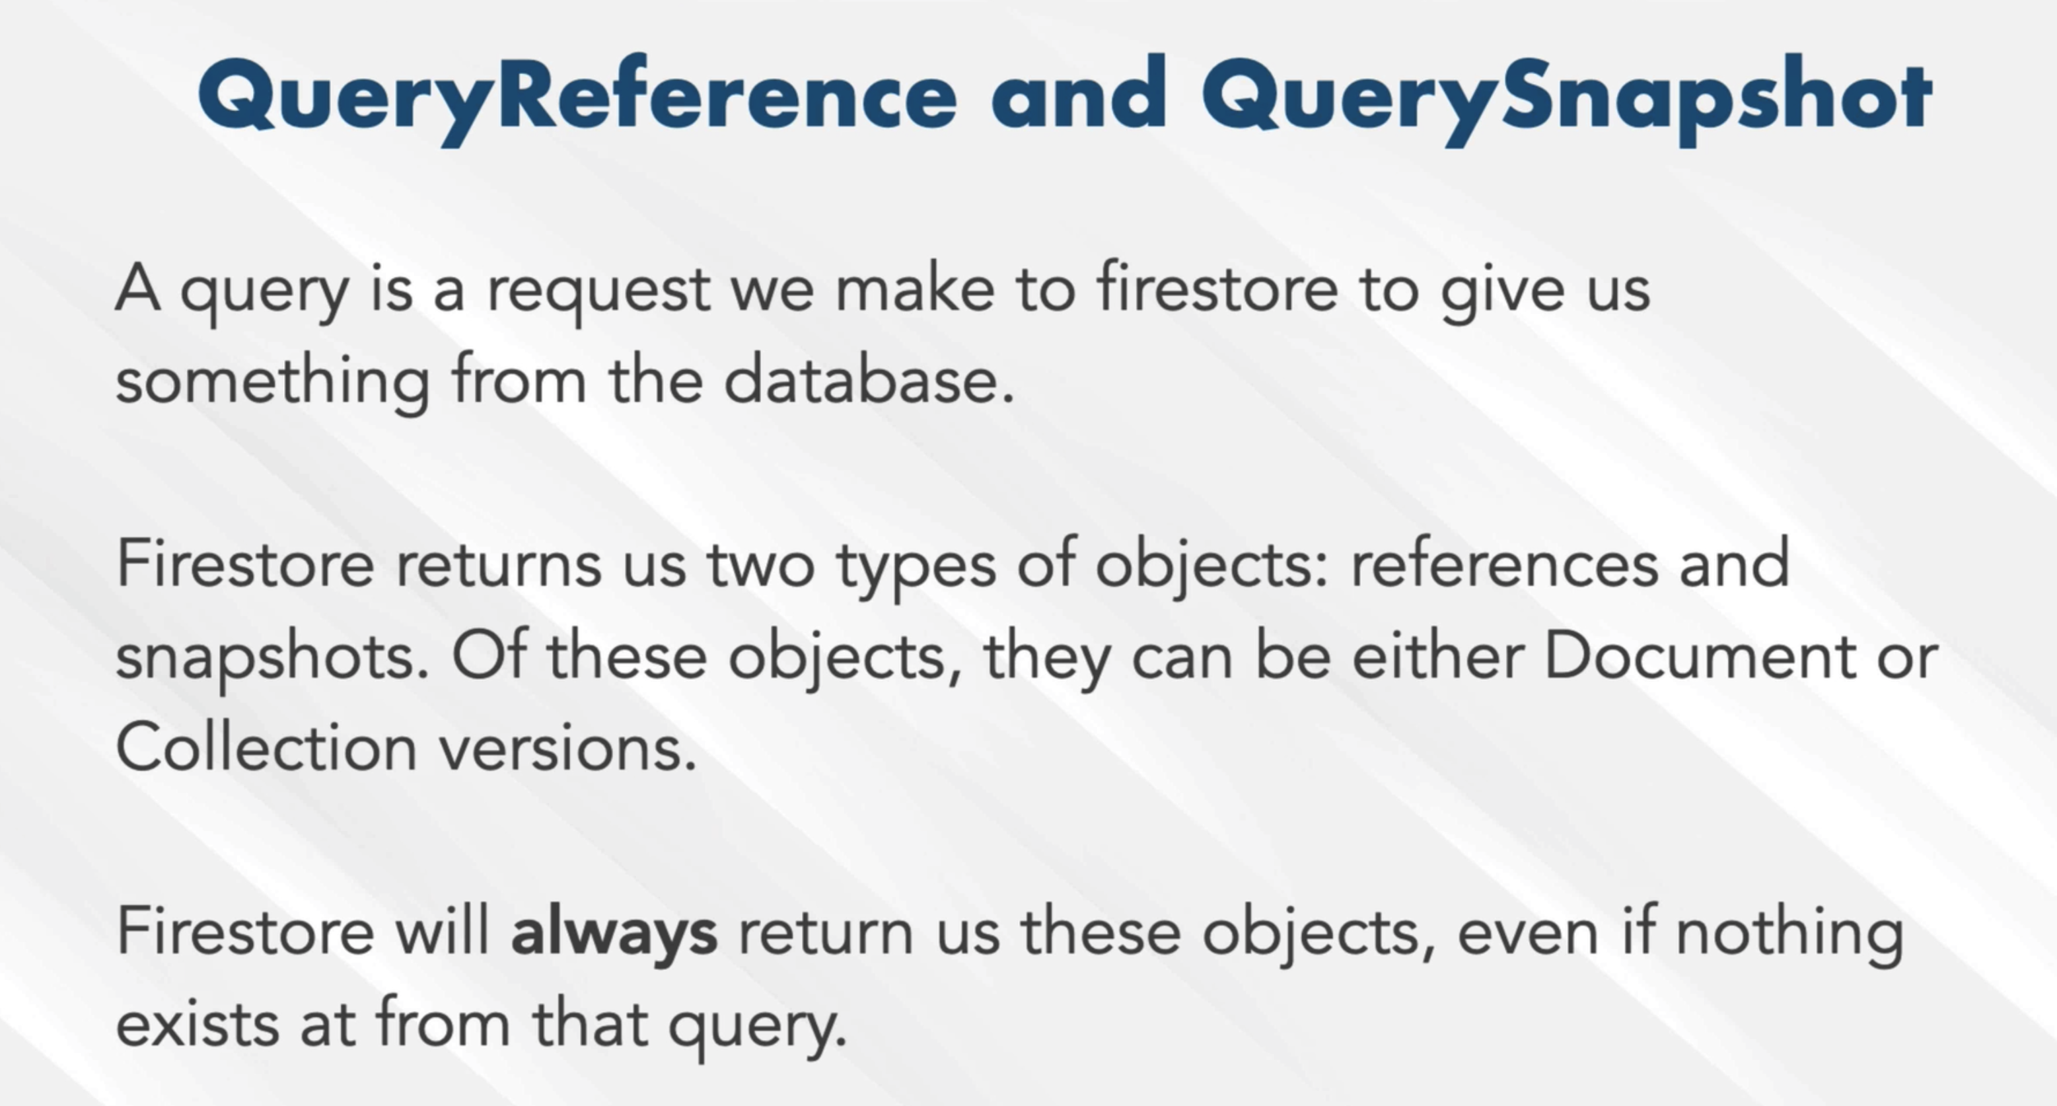

QueryReference is always returned by FS whether there’s content or not. This will enable the app whether to save or not the

data.

.get() will enable for the firesbase to throw a Document Snapshot object

f. 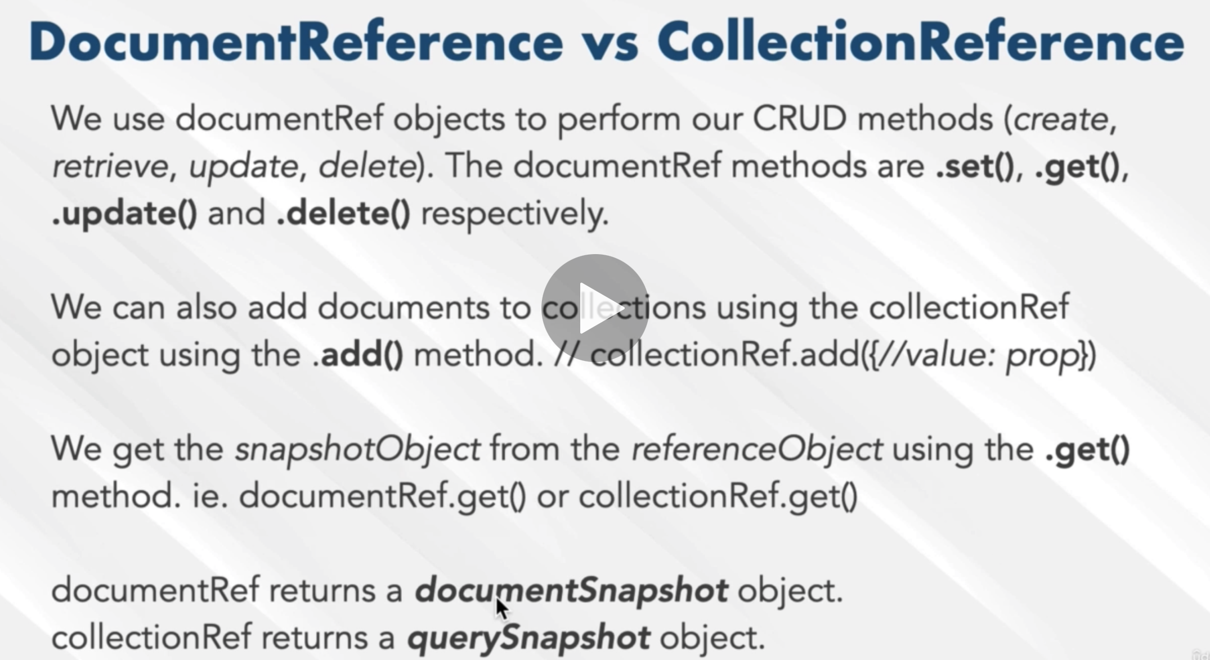

**DocumentReference is where the CRUD happen**s

h. 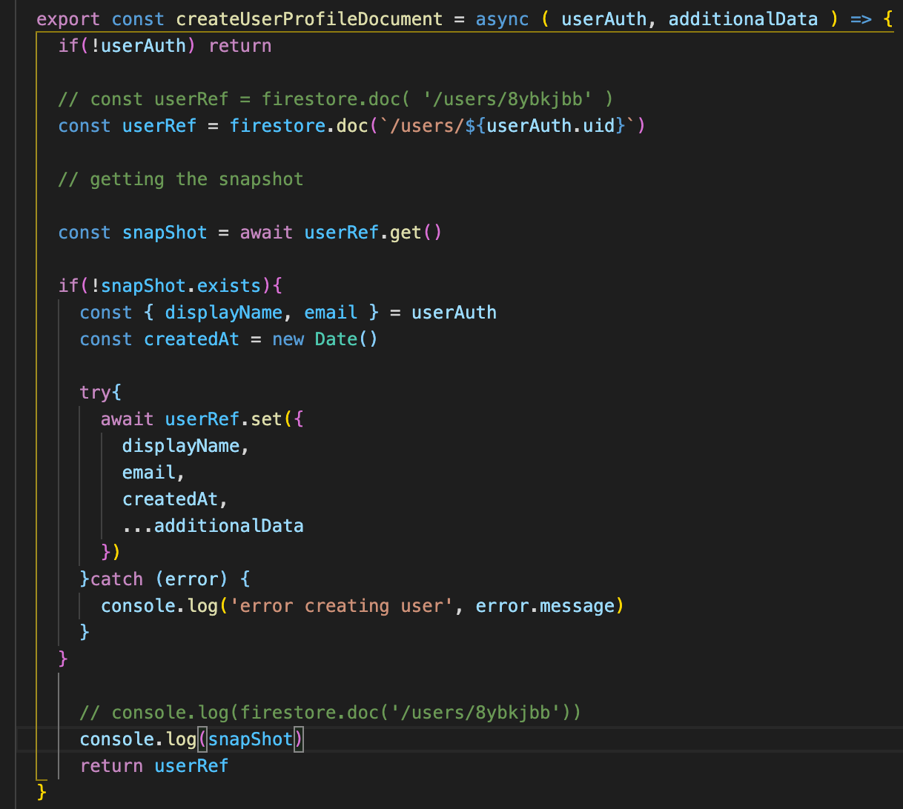

i. const userRef = firestore.doc(`/users/${userAuth.uid}`) <<< is to query

j. const snapShot = userRef.get() <<< is the snapshot result of the query

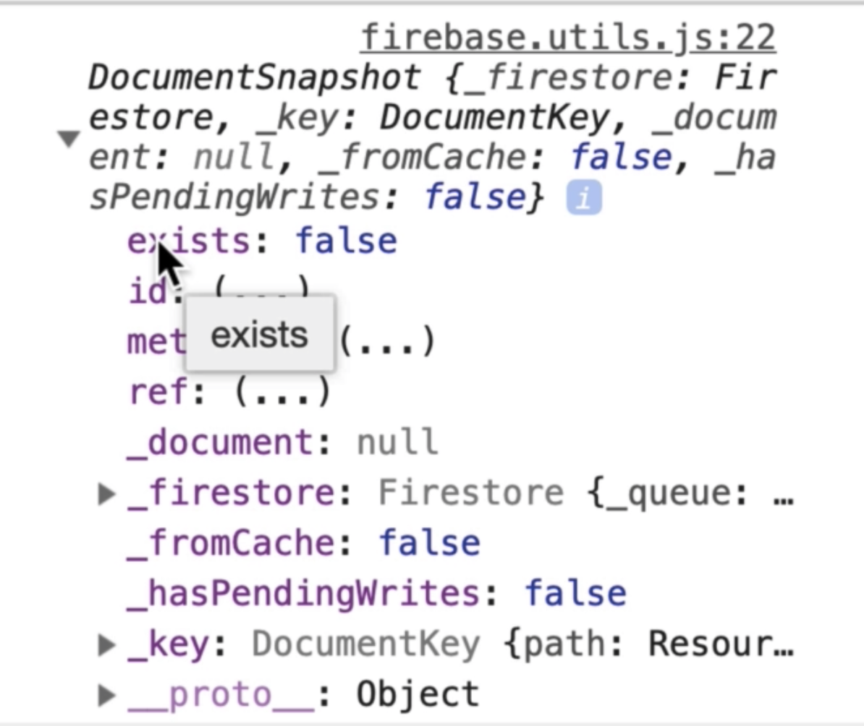

k. below check if the status of the snapshot. If there’s no data in the snapshot the the data inside the try block will be created. Return the userRef for future use

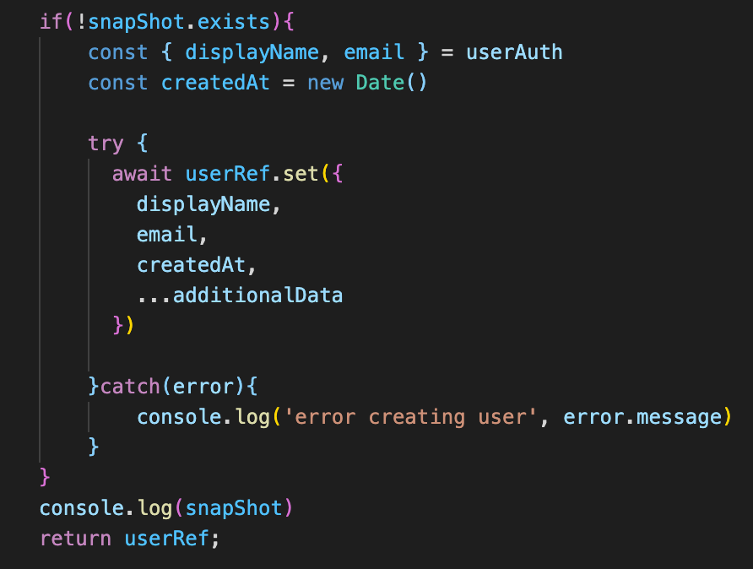

l. from here we can see that the user is now in the database. The data also persist even if the page is refresh. The app will only

create if the userAuth object don’t exist.

m. the exists property tells whether there’s a document or none.

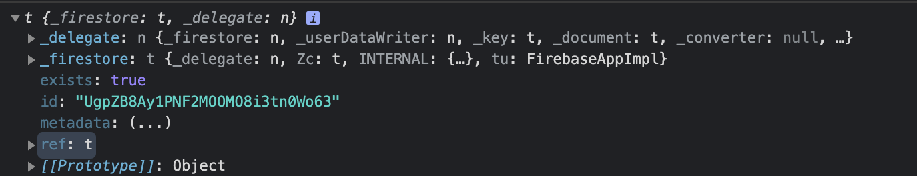

n. ref = document reference and parent = collection reference

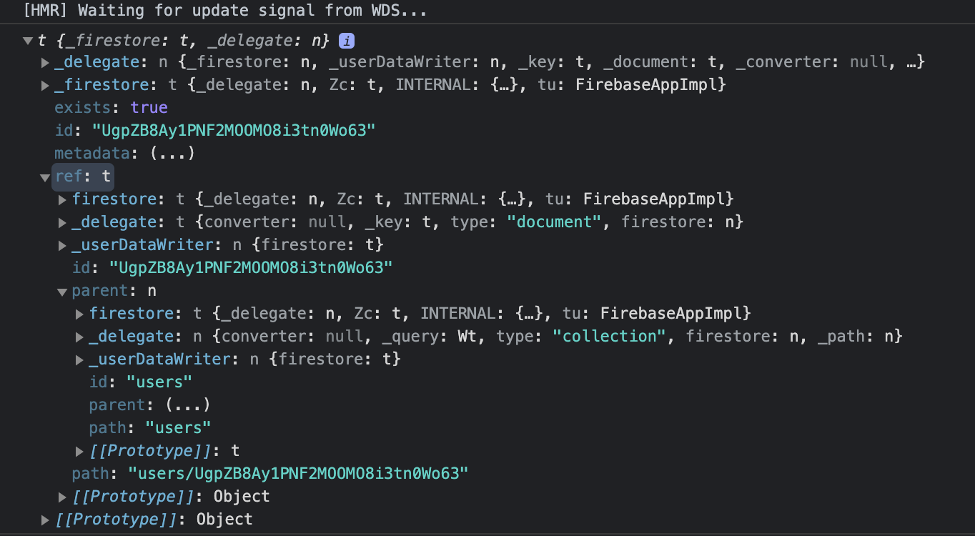

o. Summary

It all starts in the userAuth object returned by the auth library. The object can either contain(logged-in) or don’t contain

any data(not logged-in)

i. create the createUserProfileDocument = async (userAuth, additionalData) => {}. It’s an async as it requests information

from the firebase

ii. if(!userAuth) return = if there’s no userAuth meaning if the user is not logged in do nothing. This will return null

iii. const { displayName, email } = userAuth >>> destructure the userAuth and take the displayName and email

iv. const createdAt = new Date() >>>> log the date when it was created

v. const userRef = firestore.doc(`users/${userAuth.uid}`) <<< this is the query to get the uid from userAuth object

vi. const snapShot = userRef.get() <<< this is getting the uid from the userAuth

vii. if(!snapShot.exists){ create the document } then wrap it in a try – catch block. If the document exists, the app will just persist and will not re-create the same document.

viii. import the createUserProfileDocument to <App> and pass it to componentDidMount(){} replacing the this.setState() as the parameter to be rendered in the <Header> later.

ix. Below shows that the document was created base from the userAuth object.

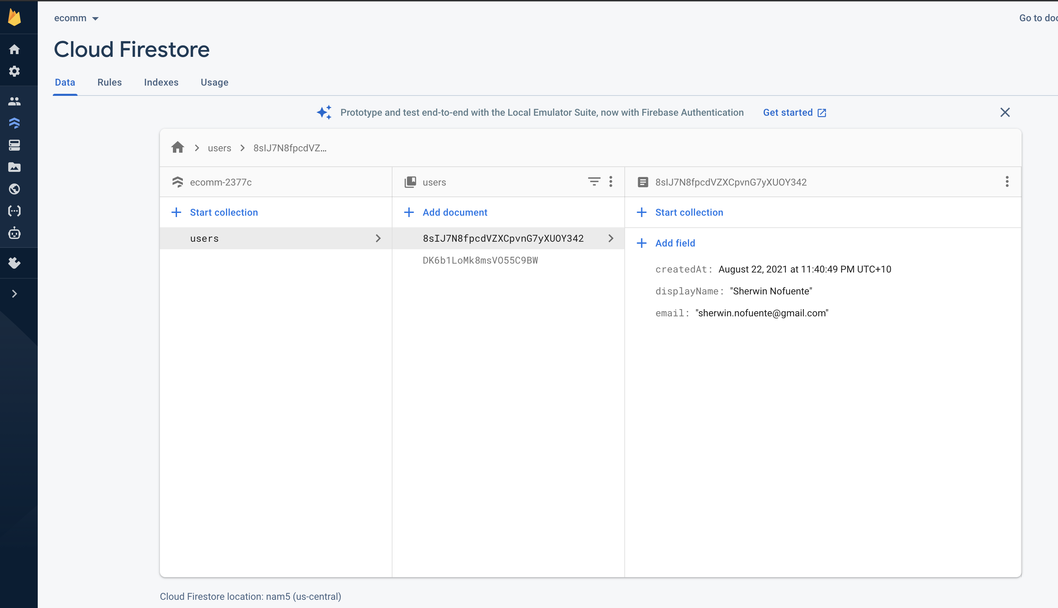

103. Firestore update regarding permissions

104. Storing user data or state in the app

a. In the <App>, componentDidMount, change the async ‘user’ to async userAuth as we’re now using the userAuth object from

the auth library.

b. if(userAUth){ >>> this check if there’s a userAuth object

const userRef = createUserProfileDocument(userAuth) <<< modified from user to userAuth

userRef.snapShot( snapSHot => { <<< calling the snapSHot to check the user state and assign it to currentUser

this.setSTate({

currentUser: {

id: snapShot.Id <<< can get the id by not using the .data()

…snapShot.data() <<<< the .data is a documentSnapshot method to display the data

}

})

} )

this.setState({ currentUser: userAuth }) <<< this still render the state of the user if it is not log in

}

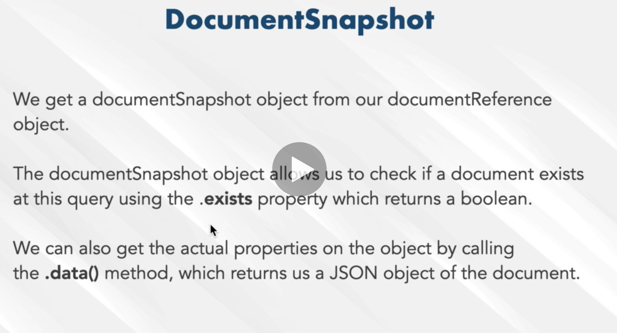

With .data()

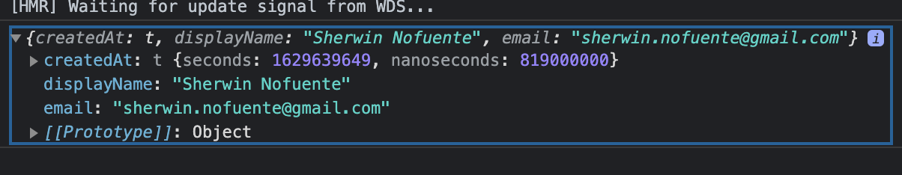

Without .data()

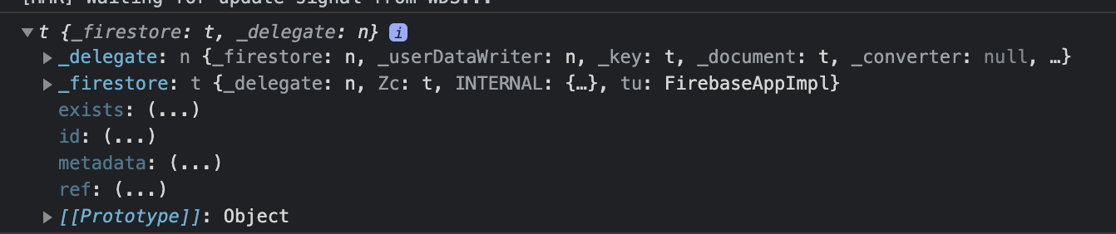

105. Sign up Component

a. create the <Signup>

106. Sign up with Email and Password

107. Sign in with Email and password.

I. At the Signin.jsx

a. The handleSubmit is very similar to auth.createUserWithEmailAndPassword. only that it will use the

auth.signInWithUserAndEmailPassword

b.

=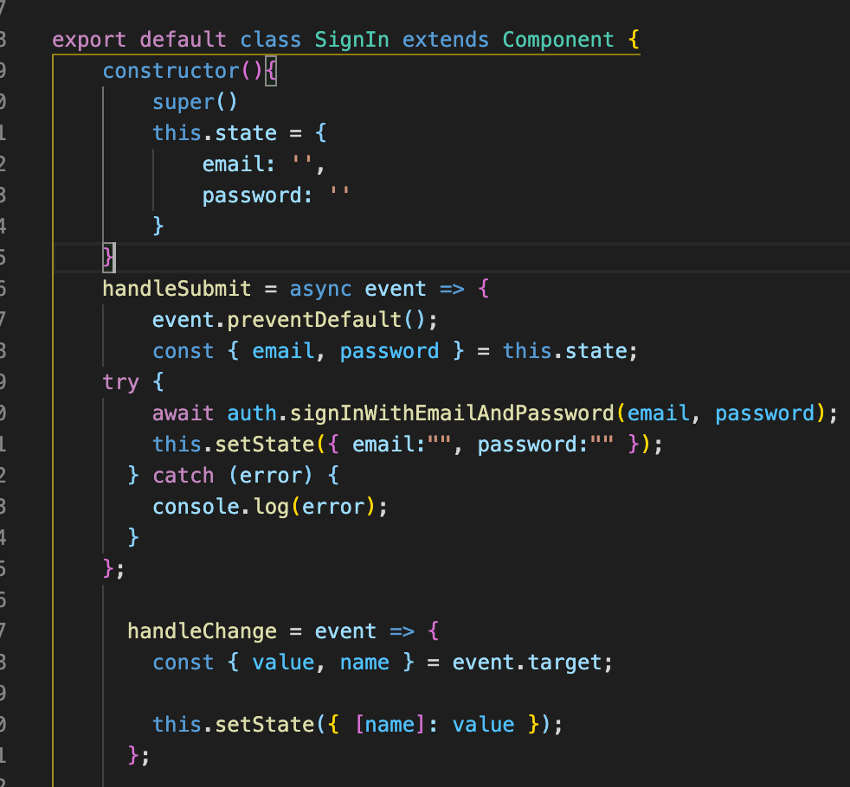

FIREBASE SUMMARY

1. Firebase installation, login to firebase and create the app. Get the sdk to be issued by firebase after app creation.

2. Create the utility.js

I. At the firebase.utils.js <<< this is the firebase utility file

a. Import vital components from firebase namely the firebase, auth and firestore

b. create the const config and use the sdk given by firebase for each app

c. firebase.initializeApp(config) – this initiates the const config

3. User authentication

I. At firebase.utils.js

a. create the const provider = new firebase.auth.GoogleAuthProvider() – this will utilize the Google authentication functions

b. provider.setCustomParameters({ prompt: ‘select_account’ }) – this is to enable the google sign in prompt

c. export const signInWithGoogle = () => auth.signInWithPopup(provider).

d. Export default firebase, auth and firestore

II. At the Google Firebase Webpage

a. make sure to enable the Google authentication. Go to Project Overview > Authentication tab



II. At Signin.jsx

a. Import the signInWithGoogle

b. create another <CustomButton onClick={ signInWithGoogle }> <<< this will trigger the pop up to appear

c. Save the file, the App now has the capability for user login and authentication.

d. Verify this at the Firebase webpage, below is the auth object created after signing in using the firebase. Auth.GoogleAuthProvider. This object will later be the userAuth object which will be use to extract the information needed to be stored in the firestore.



4. Utilize the auth object in 3.II.d. This will make the App be able to listen about the user state

I. At the <App>

a. import { auth } from ‘firebase’

b. Convert the <App> from functional to class component so that it can have an access to this.state.

c. this.state = { currentUser: null }

d. utilize the firebase method **auth.onAuthStateChange** to monitor the user state. It will take a function that retains a parameter ‘user’ which is the object that was created by auth library during user sign in, see 3.II.d. Use it in:

componentDidMount(){ auth.onAuthStateChange( user => this.setState({ currentUser: user }) ) }

e. display the currentUser state in the <Header>, pass the ‘user’ object as a props

f. <Header currentUser={ this.state.currentUser } >

II. At the <Header>

a. import { auth } from firebase.utils.js

b. Utilize the state passed from <App> as a props in <Header>, destructure the ({ currentUser }) and use it in a ternary operation to determine the SIGN IN and SIGN OUT state of the header.

{ currentUser ? <div> SIGN OUT </div> : <Link> SIGN IN </Link> }

5. Sign Out function

I. At the <Header>

a. <div className=’option’ onClick={ () => auth.signOut() } SIGN OUT </div>

II. At the <App>

a. use the unsubscribeFromAuth = null

b. at the componentDidMount(){ this.unsubscribeFromAuth = () => auth.onAuthStateChanged({ currentUser: user }) }

c. use componentWillUnmount(){ this.unsubscribeFromAuth() }

d. this will ensure that there’s no memory leak when the user sign out.

6. Firestore – Store the authenticated user to the database

I. In the FB Page

a. create the database

b. set the security to test

c. The objective here is to use the userAuth (an object created after user sign in) to determine if the user signed in or not.

d. If the user exists, then get the value of uid, email and displayName

II. At the firebase.utils.js

a. Create the createUserProfileDocument = async (userAuth, additionalData) => {} userAuth & additionalData serves as

the parameters.

b. if(!userAuth) return = if there’s no userAuth meaning if the user is not logged in do nothing. This will return null. This is

a check if the user logged in or not.

c. const { displayName, email } = userAuth >>> destructure the userAuth and take the displayName and email

d. const createdAt = new Date() >>>> log the date when it was created

e. const userRef = firestore.doc(`users/${userAuth.uid}`) <<< **this is the query** in the users/${userAuth.uid} location

f. const snapShot = userRef.get() <<< this is the **snapshot result** of the query. This checks if a doc base from uid exists or

not

g. if(!snapShot.exists){ create the document } then wrap it in a try – catch block. If the document exists, the app will just persist and will not re-create the same document. If !snapShot.exists, a document is to be created.

i. uid, displayName and email will be the composition of the document which were extracted from the userAuth; { uid, displayName, email } = userAuth

h. Return userRef for later use

III. At the <App> - this for the front end to be able to use the user data (userRef) from back end

a. import the createUserProfileDocument to <App> and pass it to componentDidMount(){} replacing the this.setState() as the parameter to be rendered in the <Header> later.

b. Get the onSnapshot of the userRef, it will return a parameter snapshot. Use snapshot and it can get the snapshot.id.

use the snapshot.data() and it can retain the details like displayName, email etc.

c. use the data in b to currentUser